# EX.NO:5 DATE:4.09.2024

**CREATING VIEWS**

After the completion of this exercise, students will be able to do the following:

* Describe a view
* Create, alter the definition of, and drop a view
* Retrieve data through a view
* Insert, update, and delete data through a view
* Create and use an inline view

# View:

A view is a logical table based on a table or another view. A view contains no data but is like a window through which data from tables can be viewed or changed.The tables on which a view is based are called base tables.

# Advantages of Views:

* To restrict data access
* To make complex queries easy
* To provide data independence
* To present different views of the same data

# Classification of views:

1. Simple view
2. 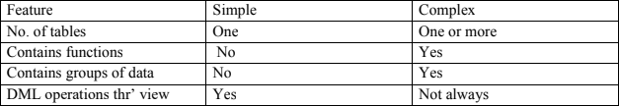Complex view

CREATE OR REPLACE FORCE/NOFORCE VIEW view_name AS Subquery WITH CHECK

OPTION CONSTRAINT constraint WITH READ ONLY CONSTRAINT constraint; FORCE - Creates the view regardless of whether or not the base tables exist.

NOFORCE - Creates the view only if the ase table exist.

WITH CHECK OPTION CONSTRAINT-specifies that only rows accessible to the view can be inserted or updated.

WITH READ ONLY CONSTRAINT-ensures that no DML operations can be performed on the View.

**Example: 1** (Without using Column aliases)

Create a view EMPVU80 that contains details of employees in department80.

# Example 2:

CREATE VIEW empvu80 AS SELECT employee_id, last_name, salary FROM employees WHERE department_id=80;

**Example:1** (Using column aliases) CREATE VIEW salvu50

AS SELECT employee_id,id_number, last_name NAME, salary *12 ANN_SALARY FROM employees

WHERE department_id=50; Retrieving data from a view Example:

SELECT * from salvu50; Modifying a view

A view can be altered without dropping, re-creating. Example: (Simple view)

Modify the EMPVU80 view by using CREATE OR REPLACE.

CREATE OR REPLACE VIEW empvu80 (id_number, name, sal, department_id) AS SELECT employee_id,first_name, last_name, salary, department_id

FROM employees

WHERE department_id=80;

**Example:** (complex view)

CREATE VIEW dept_sum_vu (name, minsal, maxsal,avgsal)

AS SELECT d.department_name, MIN(e.salary), MAX(e.salary), AVG(e.salary) FROM employees e, department d

WHERE e.deparment_id=d.deparment_id GROUP BY d.department_name;

# Rules for performing DML operations on view

* Can perform operations on simple views
* Cannot remove a row if the view contains the following:
* Group functions
* Group By clause
* Distinct keyword
* Cannot modify data in a view if it contains
* Group functions
* Group By clause
* Distinct keyword
* Columns contain by expressions
* Cannot add data thr‘ a view if it contains
* Group functions
* Group By clause
* Distinct keyword
* Columns contain by expressions
* NOT NULL columns in the base table that are not selected by the view

**Example:** (Using the WITH CHECK OPTION clause) CREATE OR REPLACE VIEW empvu20

AS SELECT *

FROM employees WHERE department_id=20

WITH CHECK OPTION CONSTRAINT empvu20_ck;

Note:Any attempt to change the department number for any row in the view fails because it violates the WITH CHECK OPTION constraint.

**Example** – (Execute this and note the error)

UPDATE empvu20 SET department_id=10 WHERE employee_id=201;

# Denying DML operations

**Use of the WITH READ ONLY option.**

Any attempt to perform a DML on any row in the view results in an oracle server error. Try this code:

CREATE OR REPLACE VIEW empvu10(employee_number, employee_name,job_title) AS SELECT employee_id, last_name, job_id

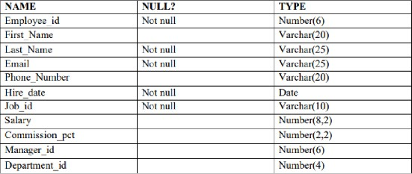FROM employees WHERE department_id=10 WITH READ ONLY;

CREATE TABLE Employee (

Employee_id NUMBER(6) NOT NULL, First_Name VARCHAR2(20),

Last_Name VARCHAR2(25) NOT NULL, Email VARCHAR2(25) NOT NULL,

Phone_Number VARCHAR2(20), Hire_date DATE NOT NULL, Job_id VARCHAR2(10) NOT NULL, Salary NUMBER(8,2),

Commission_pct NUMBER(2,2), Manager_id NUMBER(6), Department_id NUMBER(4),

CONSTRAINT pk_employee PRIMARY KEY (Employee_id)

);

INSERT INTO Employee (Employee_id, First_Name, Last_Name, Email, Phone_Number, Hire_date, Job_id, Salary, Commission_pct, Manager_id, Department_id)

VALUES (101, 'Amit', 'Sharma', 'amit.sharma@example.com', '9123456789', TO_DATE('2021- 03-01', 'YYYY-MM-DD'), 'IT_PROG', 60000, NULL, 100, 50);

INSERT INTO Employee (Employee_id, First_Name, Last_Name, Email, Phone_Number, Hire_date, Job_id, Salary, Commission_pct, Manager_id, Department_id)

VALUES (102, 'Sita', 'Patel', 'sita.patel@example.com', '9123456790', TO_DATE('2020-05-12', 'YYYY-MM-DD'), 'HR_REP', 45000, NULL, 101, 30);

INSERT INTO Employee (Employee_id, First_Name, Last_Name, Email, Phone_Number, Hire_date, Job_id, Salary, Commission_pct, Manager_id, Department_id) VALUES (103, 'Rahul', 'Verma', 'rahul.verma@example.com', '9123456791', TO_DATE('2019-07-23', 'YYYY- MM-DD'), 'SA_MAN', 70000, 0.1, 101, 80);

INSERT INTO Employee (Employee_id, First_Name, Last_Name, Email, Phone_Number, Hire_date, Job_id, Salary, Commission_pct, Manager_id, Department_id) VALUES (104, 'Priya', 'Singh', 'priya.singh@example.com', '9123456792', TO_DATE('2022-08-17', 'YYYY- MM-DD'), 'FI_ACCOUNT', 50000, NULL, 102, 50);

INSERT INTO Employee (Employee_id, First_Name, Last_Name, Email, Phone_Number, Hire_date, Job_id, Salary, Commission_pct, Manager_id, Department_id) VALUES (105, 'Rohan', 'Reddy', 'rohan.reddy@example.com', '9123456793', TO_DATE('2020-11-02', 'YYYY- MM-DD'), 'ST_CLERK', 35000, NULL, 101, 50);

INSERT INTO Employee (Employee_id, First_Name, Last_Name, Email, Phone_Number, Hire_date, Job_id, Salary, Commission_pct, Manager_id, Department_id) VALUES (106, 'Kiran', 'Nair', 'kiran.nair@example.com', '9123456794', TO_DATE('2018-09-25', 'YYYY-MM- DD'), 'IT_PROG', 65000, NULL, 100, 60);

INSERT INTO Employee (Employee_id, First_Name, Last_Name, Email, Phone_Number, Hire_date, Job_id, Salary, Commission_pct, Manager_id, Department_id) VALUES (107, 'Anjali', 'Desai', 'anjali.desai@example.com', '9123456795', TO_DATE('2021-12-05', 'YYYY- MM-DD'), 'HR_REP', 47000, NULL, 102, 30);

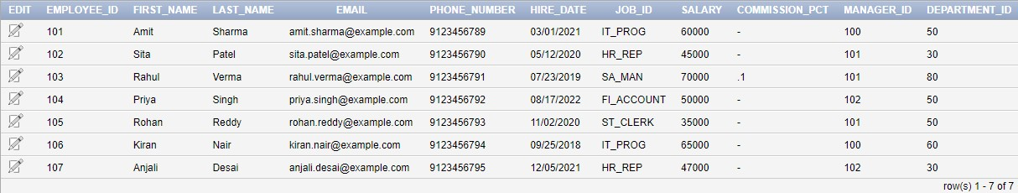

# Find the Solution for the following:

1. **Create a view called EMPLOYEE_VU based on the employee numbers, employee names and department numbers from the EMPLOYEES table. Change the heading for the employee**

# name to EMPLOYEE.

CREATE VIEW EMPLOYEE_VU AS

SELECT Employee_id,

First_Name || ' ' || Last_Name AS EMPLOYEE, Department_id

FROM Employee;

# Display the contents of the EMPLOYEES_VU view.

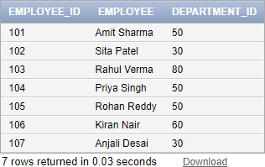SELECT * FROM EMPLOYEE_VU;

# Select the view name and text from the USER_VIEWS data dictionary views.

SELECT view_name, text FROM user_views

WHERE view_name = 'EMPLOYEE_VU';



# Using your EMPLOYEES_VU view, enter a query to display all employees names and department.

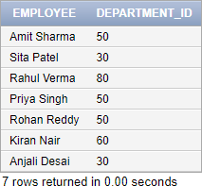SELECT EMPLOYEE, Department_id FROM EMPLOYEE_VU;

# Create a view named DEPT50 that contains the employee number, employee last names and department numbers for all employees in department 50.Label the view columns EMPNO,

**EMPLOYEE and DEPTNO. Do not allow an employee to be reassigned to another department**

# through the view.

CREATE VIEW DEPT50 AS

SELECT Employee_id AS EMPNO, Last_Name AS EMPLOYEE, Department_id AS DEPTNO

FROM Employee

WHERE Department_id = 50 WITH READ ONLY;

# Display the structure and contents of the DEPT50 view.

DESC DEPT50;

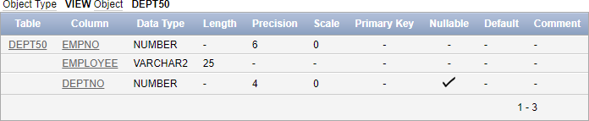

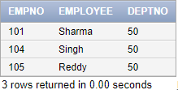SELECT * FROM DEPT50;

# Attempt to reassign Matos to department 80.

UPDATE DEPT50 SET DEPTNO = 80

WHERE EMPLOYEE = 'Matos';

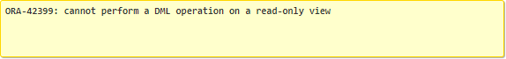This should fail due to the READ ONLY constraint.

# Create a view called SALARY_VU based on the employee last names, department names, salaries, and salary grades for all employees. Use the Employees, DEPARTMENTS and

**JOB_GRADE tables. Label the column Employee, Department, salary, and Grade respectively.**

CREATE VIEW SALARY_VU AS SELECT

e.Last_Name AS Employee, d.Dept_name AS Department, e.Salary AS Salary, jg.Grade_level AS Grade

FROM

Employee e JOIN

Department d ON e.Department_id = d.Dept_id JOIN

Job_Grade jg ON e.Salary BETWEEN jg.Lowest_sal AND jg.Highest_sal;

SELECT * FROM SALARY_VU;

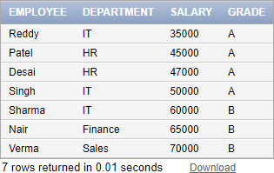

# RESULT:

Hence, views are created and executed successfully.